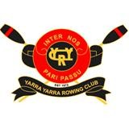 | Introduction to Rowing  Course Information  February 2024 | YARRA YARRA ROWING CLUB
 | Introduction to Rowing  Course Information  February 2024 | 2 Boathouse Drive,  Princes Bridge,  Melbourne, Vic 3004 | ABN 356 723 804 64
www.yyrc.com.au email: learnrowing@yyrc.com.au

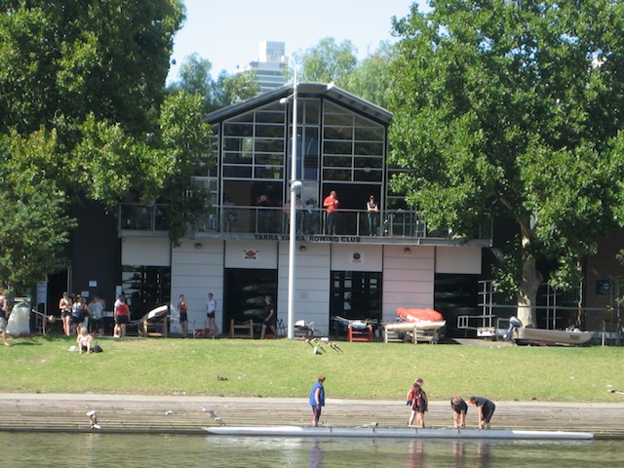

Session 1 Sunday 4 February 9am
9.00-9.20: Welcome and Visitor Induction
Tour of the shed
Warm up on rowing machines, rowing in a team
9.20-9.40: Boat preparation and organising –
Rowing on the Yarra- technique
10.15-10.30 Cleaning the boats / Stretching / Conclude

Session 2 Thursday 8 February 6pm
6.00- 6.20: Review Boat Terminology, power, ratios and exercises for improving technique and fitness
6.20—7.45: Basic Rowing Technique and Boat Terminology, Instruction on rowing (ergo) machines, rowing in a team
7.45 8.00 Cleaning the boats / Stretching / Conclude

Session 3 Sunday 11 February 9am
9.00- 9.10: Review Boat Terminology, power, ratios and exercises for improving technique and fitness
9.10- 11.30: Further Rowing Technique on rowing (ergo) machines, team rowing exercises
9.30 – 10.45 Rowing on the Yarra- technique and power
10.45– 11.00 Cleaning the boats / Stretching / Conclude

Session 4: Thursday 15 February 6pm
6.00-6.15 Review Boat Terminology, power, ratios and exercises for improving technique and fitness
Warm up on rowing machines, rowing in a team
6.15- 7.45 Boat preparation and organising- Rowing on the Yarra
7.45- 8.00 Cleaning the boats / Stretching / Conclude

Session 5 Sunday 18 February 9am
9.00-9.15 Review on rowing (ergo) machines
9.15-10.15 Rowing on the Yarra- rhythm and timing
10.15-10.30 Cleaning the boats / Stretching / Conclude

NOTE: This program is a typical example. Can be tailored, depending on the special requirements of rowers, number of rowers, extreme weather etc.

What to Bring - Nothing too nice, your clothing will probably get a little dirty.
- Shorts/bike shorts – preferably not baggy or Track suit -preferably not baggy (so it wont get caught in the slides)  - T-shirt – not too long or baggy so it wont get caught in the slides  - Thick socks – for wearing in the boat | - Water bottle  - Sunscreen Cap / Hat / Sunglasses  - Thongs/Reef Sandals (non Slip) -these will get wet when launching the boat

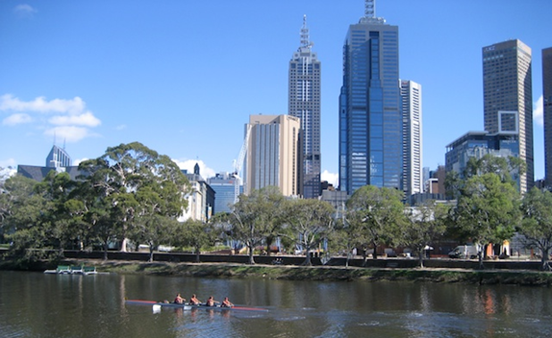
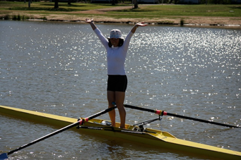

If it's cold, please bring extra layers of clothing. If there is a chance of rain, pack a light waterproof top, towel and change of clothes, as we can proceed in most weather conditions. Your belongings can be secured during training.

